Manfred Screyer
Mirage Art Photography
Call: 937.533.1291
Nov 9th – 21st, 2024
A journey that will change your life
Varanasi, also known as Benaras, Banaras or Kashi, is a city situated on the banks of Ganga River in the northern Indian state of Uttar Pradesh dating to the 11th century B.C. Regarded as the spiritual capital of India.
“This 13-day tour of Varanasi is specifically designed for the mature, educated individual, who indulges in “other” knowledge and is ready to discover an ancient, spiritual world and heritage.”
Manfred Screyer
Mirage Art Photography
Call: 937.533.1291

Culture & Heritage

- Learn about the Importance of Banaras in India. Especially for Hindus; learn about various aspects of Banaras, its many names and what makes it the cultural capital of India.
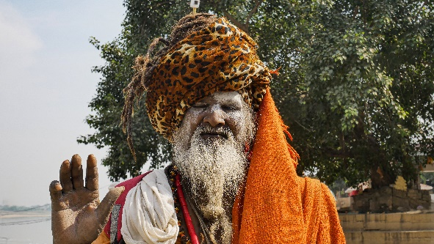
- Discover Archaeology, Mythology, Geography, and History of Banaras- its unique situation on Ganges, and its journey through the history of India, and quest to know what makes it oldest living city.
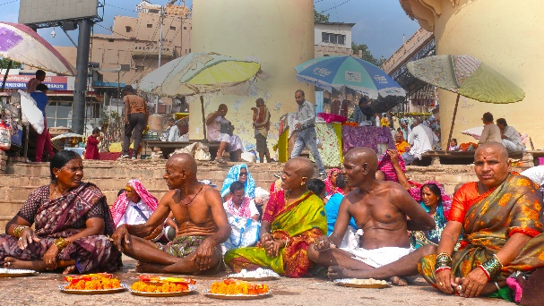
- Emerge yourself into the religious Varanasi- Many religions, place and types of worship, a religious place and institutions. You will find that even Primitive worship cults are still practiced in this city. Discover the city of Buddha, Jain Tirthankars, Shaiva and Vaishnava saints or Devoted saints like Kabir and Tulsi.
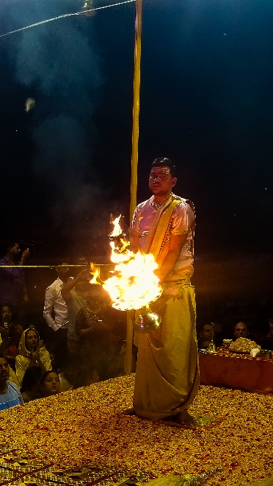
- Arts, Crafts and Architecture of Banaras: You will be amused to see that Varanasi is a museum architectural design. It presents changing patterns and movements in course of history. It has a rich and original variety of paintings and sculptor styles and equally rich treasures of folk art. During the ages Varanasi has produced master craftsmen and Varanasi has earned name and fame for its Sarees, handicrafts, textiles, Toys, ornaments, metal work, clay and wood work, leaf and fiber crafts. With ancient crafts, Banaras has not lagged behind in modern Industries.
- Discern and discover Ganga- the holiest of the holy river- its mythology, geography, socio- economic aspects, its monumental ghats and their story and the present condition of pollution.
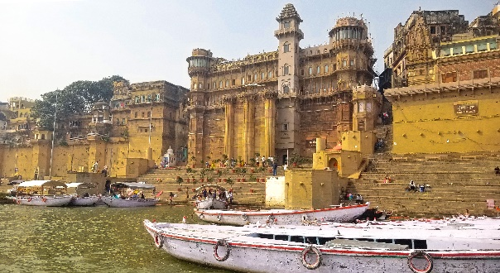
- The Capital of all knowledge- Discover the most ancient seat of education in India World the famous scholars and their `Shastrarthas’, the great scholars, universities, college, schools, Madarsas and Pathshalas and Guru Shishya traditions, the epics, famous literary works, languages and dialects, journalistic traditions- newspapers and magazine, and famous libraries.
- Take a glimpse into the social and cultural fabric- Organization of sacred complex and social spaces, the cultural pluralistic, linguistic and ethnic groups. Discover the city of affluence, intellectuals, oral traditions, castes and customs, personalities, professions, communal harmony. Discover the rural Varanasi. And finally (and with deep insight) peep into, the pleasure of Pans, Thandai, Gamcha, Bahri Alang and Mauj Masti.
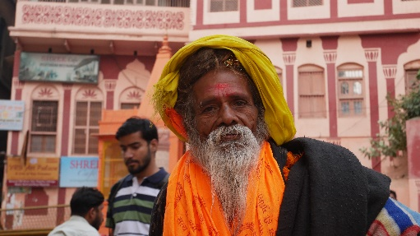
- Enjoy the City of Music and Drama and Entertainment:
Banaras has been famous for its Music both vocal instrumental, it has its own dance tradition. Add to this a very rich stock of folk Music and drama (esp. Ramlila), the tradition Musical soirees, fairs and festival the rich tradition of Akharas, games and sports. Add to this classical Banaras Transport vehicles like Ekka and Modern Traffic Jam.
Manfred Screyer
Mirage Art Photography
Call: 937.533.1291
- Recognize the industrial City: Discover the fast-developing city of heavy, light and cottage industries, local handicrafts and other small scale industrial units. (DLW, BHEL, Electric, Cycle, Pumps, Paper, Glass, Fertilizer etc.)
- Medical World of Varanasi: Discover the ancient College of Plastic Surgery, Sushruta, Dhanvantri (God of Medicine), Divodas, and practice of all the ancient and modern systems of medicine in action.

Tour Agenda:

 | AM | PM
Day 01 - Nov 09 - Sat | Leaving El Paso, TX | Flight to Varanasi, India
Day 02 - Nov 10 - Sun | Time change /  Time zone: GMT + 5:30 | Flight to Varanasi, India
Day 03 - Nov 11 - Mon | Arrival in Varanasi - Hotel | Settle in and dinner together at local restaurant
Day 04 - Nov 12- Tue | Walking to Ghats | Dashashwamedh Ghat Aaarti Service
Day 05 - Nov 13 - Wed | Breakfast discussion:  What Aarti meant to us.  Walking tour to Shree Kashi Vishvanath temple | Visit Shree Kashi Vishvanath Temple
Day 06 - Nov 14 - Thur | Walking & Experience Manikarnika Ghat | Walking the Ghats
Day 07 - Nov 15 - Fri | Boat ride on Ganges River | Celebration:  Deepawali will be celebrated on 15th November. Per the Drikpanchang, the Purnima Tithi begins at noon on 15th November 2024 and ends at 05:10 pm on 19th November 2024.
Day 08 - Nov 16 - Sat | Visit of local craft & textile market | Visiting Dhamek Stupa - The Dhamek Stupa was constructed in 500 CE to replace an earlier structure, and has been enlarged on several occasions over the years. It measures 28 meters in diameter at its base and almost 44 meters in height. It sits on beautifully manicured gardens, and the immediate vicinity is home to a number of half-ruined monasteries and the remains of much smaller stupas along with a museum and a number of temples.
Day 09 - Nov 17 - Sun | Visit Ramnagar Fort | Remainder of day/evening off
Day 10 - Nov 18 - Mon | Visit Banaras Hindu University compound & Museum | Street vendor food tour
Day 11 - Nov 19 -Tue | Walking tour of Varanasi | Walking tour of Varanasi
Day 12 - Nov 20 - Wed | Debriefing and discussion of experiences | Afternoon off
Day 13 - Nov 21 - Thur | Leaving Varanasi | Flight to El Paso

Your 10-day hotel accommodations (included in tour pricing):
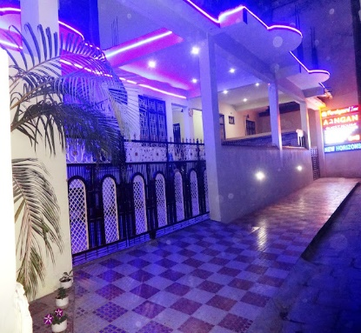 | 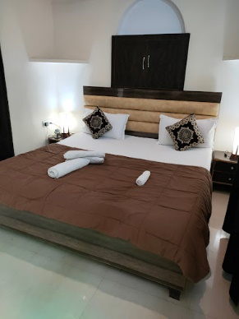 | 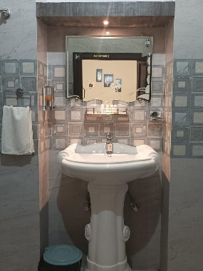 | 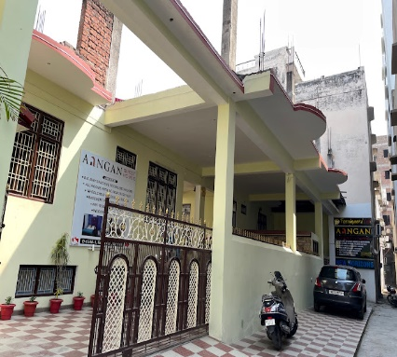
A heritage property more than 100 years old, yet very sturdy and well-maintained.
- At a comfortable walking distance (about 600 meters), from world-famous Kashi-Vishwanath Dham and Dashashwamedh Ghat
- Very Open and airy premises with big-size rooms and facilities spread in more than 7,000 SqFt (800 SqYds)
- In the heart of Varanasi City yet very peaceful and quiet ambience and surrounding
- Brand new beds, beddings, furniture, furnishings in a well-lit decorative surrounding
- Very safe and secured with 24-hours guard service - CCTV Cameras provided in and around the premises
- Fire protection facilities installed around the premises
- Access to motor vehicles and other means of transport
- 24 Hours tea, cappuccino (Coffee ), Green tea and cold Drinks Vending Machines AMENITIES:
- Airy and spacious rooms and bathrooms - All rooms equipped with AC, heater (chargeable) and Geyser - 24 Hours Electricity, hot and cold Water in shower and basins
- Complimentary Wi-Fi
- Alexa-enabled rooms
- Large size TV in each room
- Wheelchair accessible
- Laundry and ironing services
Manfred Screyer
Mirage Art Photography
Call: 937.533.1291
Manfred Screyer
Mirage Art Photography
Call: 937.533.1291

Included in this tour:

Assistance of preparations of travel documents and visa for India.
Assistance in departure from main US airport of El Paso, TX.
International flights: US - Varanasi - US.
24 hour -Tour guide by veteran India traveler, international photojournalist/filmmaker Manfred Schreyer
10 nights hotel accommodation in local historic hotel.
10 Breakfasts.
Manfred Screyer
Mirage Art Photography
Call: 937.533.1291
Transfers with English speaking assistant in air-conditioned vehicles.
Visits and entrance fees as indicated in the itinerary.
All air taxes and fuel surcharge.
Private transfers in Varanasi, airport-hotel-airport, with complimentary bottled water.

Things you must know:
1. The cancellation policy is applicable is accordance to the Terms and Conditions available and agreed at the time of your purchase. (Either attached to this document or linked on the web)
2. If you are traveling to India with a U.S. passport, you will require an Indian visa. For other nationality passport holders, we recommend that you check with the Indian Embassy for further details: https://www.indianvisaonline.gov.in/visa/tvoa.html. I can assist you with the process.
3. You will need a passport with a minimum of six months validity beyond date of visa application and two blank passport pages.
4. Currency: Indian Rupee.
5. Language: Hindi and English.
6. Electricity: 220 V in the majority of the country. Electrical sockets are European style however an adapter may be useful.
7. Time zone: GMT + 5:30.
8. You must be 25 years or older to join this travel tour.

Not included in the price:
1. Fees, drinks, food, tips and any other services not mentioned in what's included. (Food at restaurants and other services are incredibly cheap.)
Manfred Screyer
Mirage Art Photography
Call: 937.533.1291
Other useful information:
https://www.smithsonianmag.com/travel/the-holy-city-of-varanasi-42862228/

TOTAL PRICE for 13-day tour to Varanasi, India:
1. Experienced Tour Guide
2. Flight from El Paso to Varanasi, India El Paso (Economy class),
3. Hotel w. Breakfast
Only $3650.00/person
Limited to 6 people ONLY (no children)
Registration deadline for this trip is May 31st - 2024
Payment plan available, Visa, Mastercard.
contact:
Manfred Schreyer
937.533.1291
contactus@mirageartphotography.com

